**PROGRAM 1b**

**-** ASHISH KUMAR  
 - 2K18/SE/041

# Aim:- Write a C++ program to implement data link layer - Character Stuffing.

**Theory:-** In byte stuffing(or character stuffing), a special byte called the escape character (ESC) is stuffed before data section of the frame when there is a character with the same pattern as the flag byte. If the ESC sequence is found in the message byte, then another ESC byte is stuffed before it. Whenever the receiver encounters the ESC character, it deletes it from the data section and treats the next character as data, not a delimiting flag.

**CODE:-**

#include<iostream>

#include<bits/stdc++.h>

#include<string.h>

using namespace std;

int main()

{

char a[30], fs[50] = " ", t[3], sd, ed, x[3], s[3], d[3], y[3];

int i, j;

/*we will consider only three types of byte sequences in the sent data, as :

F : Flag Sequence

E : Escape Sequence

D : Any other Data Sequence*/

cout<<" Enter characters to be stuffed:";

cin>>a;

cout<<"\n Enter a character that represents starting delimiter:";

cin>>sd;

cout<<"\n Enter a character that represents ending delimiter:";

cin>>ed;

x[0] = s[0] = s[1] = sd;

x[1] = s[2] = '\0';

y[0] = d[0] = d[1] = ed;

d[2] = y[1] = '\0';

strcat(fs, x);

for(i = 0; i < strlen(a); i++)

{

t[0] = a[i];

t[1] = '\0';

if(t[0] == 'F') //if we see a flag byte,then insert E before F

strcat(fs, "EF");

else if(t[0] == 'E') //if we see a ESC byte, then insert E before E

strcat(fs, "EE");

else

strcat(fs, "D"); //if we see data, then nothing will be done

}

strcat(fs, y);

cout<<"\n After character stuffing:"<< fs;

return 0;

}

**OUTPUT:-**

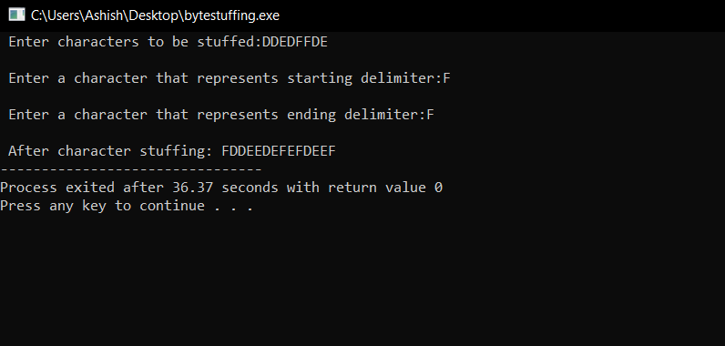

**Learning Outcome:-** We have successfully implemented Character stuffing and we learnt its application in computer network.